**Question 1:** What types of transactions should the system support? **Possible Response:** The system should handle deposits for all account types, withdrawals for investment and cheque accounts only, interest payments for savings and investment accounts, balance inquiries, and transaction history viewing. Each transaction type requires proper validation and recording.

**Question 2:** Are there any limits on deposit amounts for different account types? **Possible Response:** No maximum limits on deposits, but investment accounts require minimum BWP500 opening deposit. All deposits must be positive amounts and properly validated before processing.

**Question 3:** How should the system handle withdrawal restrictions for savings accounts? **Possible Response:** Savings accounts should completely prohibit withdrawals - this is a core business rule. The system must prevent any withdrawal attempts and clearly communicate this restriction to customers.

**Question 4:** What validation checks are needed before processing transactions? **Possible Response:** Verify account ownership, validate positive amounts, check account type restrictions, ensure sufficient balance for withdrawals, verify account status is active, and authenticate the customer performing the transaction.

**E. Interest Calculations**

**Question 5:** How frequently should interest be calculated and applied to accounts? **Possible Response:** Interest should be calculated and applied monthly. Savings accounts receive 0.05% monthly interest, investment accounts get 5% monthly interest. The system should automate this process at month-end.

**Question 6:** What security measures are most important for protecting customer data? **Possible Response:** Implement secure password requirements, encrypt sensitive data, use session timeouts, log all access attempts, restrict access based on user roles, and ensure secure database connections.

**Question 7:** Who should have access to customer account information? **Possible Response:** Only the account holder, authorized bank employees with legitimate business needs, and system administrators for maintenance purposes. All access should be logged and monitored.

**Question 8:** Could you describe the main objectives this banking system should achieve? **Possible Response:** The system should provide secure account management for customers, enable efficient transaction processing, automate interest calculations, and maintain comprehensive transaction records. It must support multiple account types while ensuring data integrity and user-friendly operations.

**Question 9:** What makes this banking system unique compared to existing solutions? **Possible Response:** This system focuses on three distinct account types with specific rules - savings accounts that don't allow withdrawals, investment accounts with minimum balance requirements, and employment-verified cheque accounts. The automated interest calculation with different rates for each account type is a key differentiator.

**Question 10:** Who are the different types of users that will interact with this system? **Possible Response:** Primary users are bank customers who need account management services. Secondary users include bank employees who assist customers and system administrators who maintain the platform.

**Question 11:** What details ought we to gather during customer registration at the bank? Key information required consists of complete name, residential address, contact details, ID documents, employment status for checking accounts, and initial deposit amounts. We require sufficient details for identity confirmation and adherence to regulations.

**Question 12:** In what way should the system authenticate customer identity at the time of login? Potential Reply: Employ a mix of username and password verification, possibly augmented with security queries. Think about introducing account lockout after unsuccessful attempts and a session timeout for safety.

**Question 13:** What occurs if customers lose their login information? Possible Response: Establish a safe password reset system utilizing authenticated contact details. Customers must be able to reset their credentials via email or phone verification, utilizing temporary access codes.

**Question 14:** Can you explain the different account types and their specific characteristics? **Possible Response:** Savings accounts allow deposits only and earn 0.05% monthly interest for long-term saving goals. Investment accounts require BWP500 minimum opening balance, allow deposits and withdrawals, and earn 5% monthly interest. Cheque accounts are for employed customers receiving salaries, allow all transactions but require employment verification.

**Question 15:** What are the rules for opening each type of account? **Possible Response:** Savings accounts have no minimum balance requirement. Investment accounts need BWP500 initial deposit. Cheque accounts require proof of employment including company name and address. All accounts need customer registration and identity verification.

**Question 16:** Should there be limits on how many accounts one customer can have? **Possible Response:** Customers should be able to hold multiple accounts of different types simultaneously. One person could have all three account types - savings, investment, and cheque - to meet different financial needs.

**Question 17:** What details need to be confirmed prior to permitting the establishment of a cheque account? Verification of employment status encompassing current employer's name, company's address, position held, and salary information. This guarantees the account fulfills its role for salary deposits and transactions related to employment.

**STRUCTURAL UML MODELLING**

**USE CASE DIAGRAM**

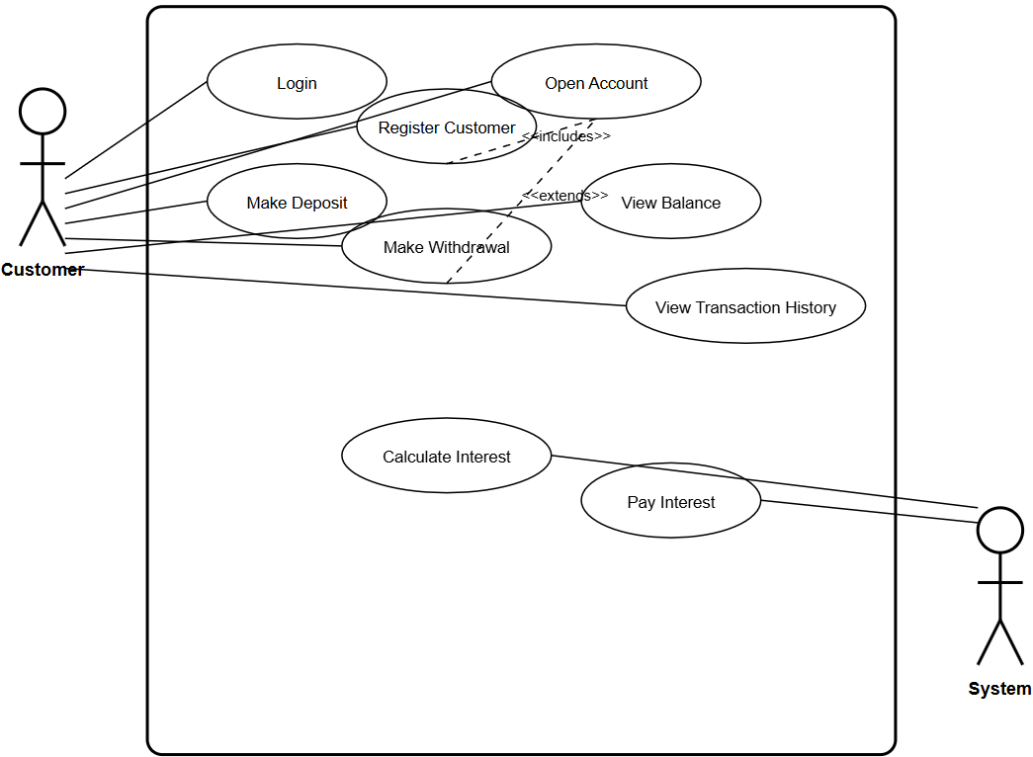

**CLASS DIAGRAM**

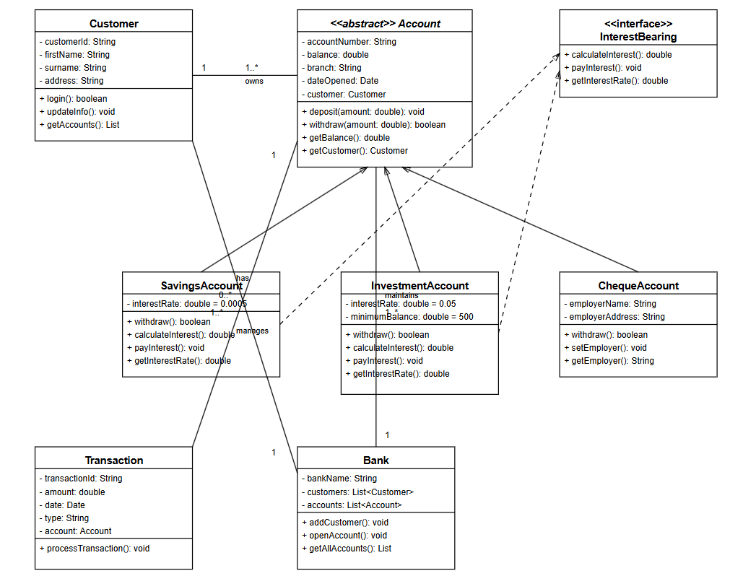

**SEQUENCE DIAGRAM (LOGIN)**

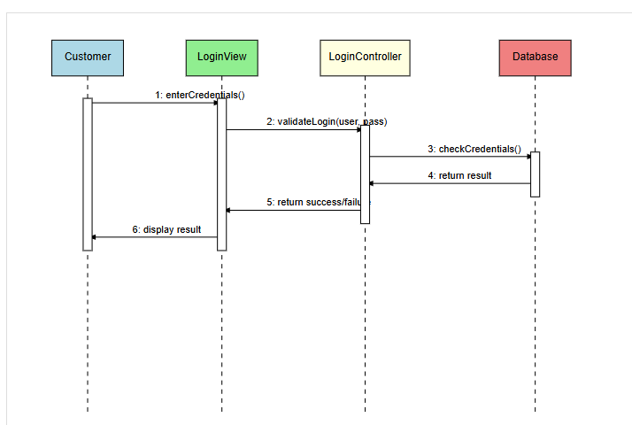

**SEQUENCE DIAGRAM (DEPOSIT FUNDS)**

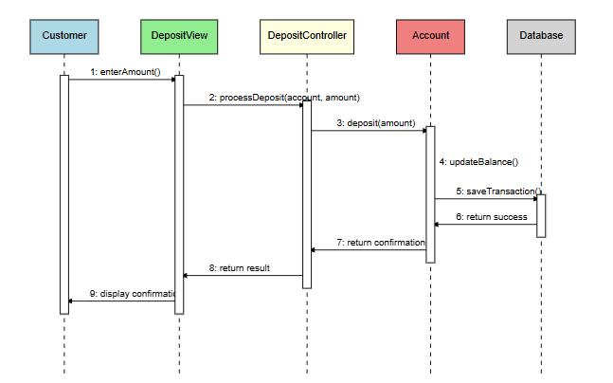

**STATE DIAGRAM**

